Simple Queries:

Simple Queries have 2 tables joined.

**Premise 01:** What products have a special offer?

**Detailed explanation of the problem:** Return all product IDs that have a special offer.

**Query**:

**Sample Output:**

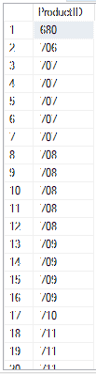

**Premise 02:** What phone numbers are the email-addresses associated with?

**Detailed explanation of the problem:** Return all Email Addresses and Phone Numbers that have the same BusinessEntityID.

**Query**: 

**Sample Output:**

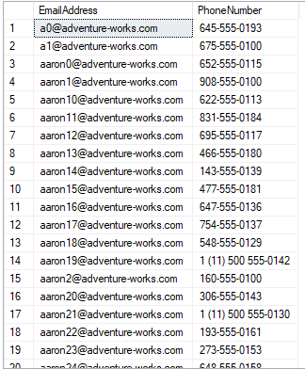

**Premise 03:** Provide the order information for the credit cards.

**Detailed explanation of the problem:** Return credit card numbers and the account numbers, order IDs, order dates, and order statuses associated with them.

**Query**: 

**Sample Output:**

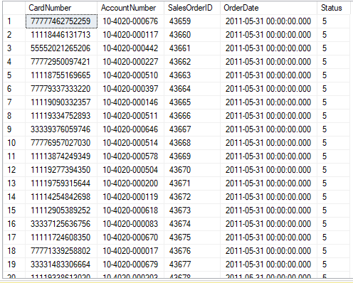

**Premise 04:** Provide the ship date, due date, and city associated with the order number?

Detailed explanation of the problem.

**Detailed explanation of the problem:** Return Order Numbers and the cities, ship dates, due dates associated with them.

**Query**: 

**Sample Output:**

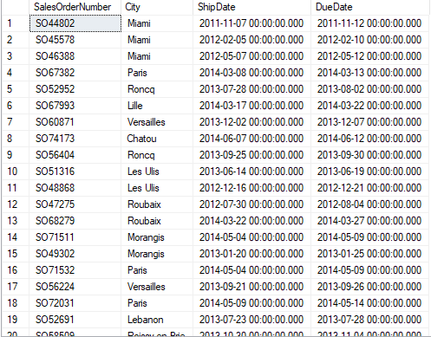

**Premise 05:** Provide information on orders with vendors with good credit rating.

**Detailed explanation of the problem:** Return Order IDs Employee IDs, Vendor IDs, total due, and the credit rating for orders that have a vendor with a credit rating greater than 3.

**Query**: 

**Sample Output:**

